Predicting Housing Prices using
Multiple Linear Regression (MLR) and K-Nearest Neighbors (KNN)

Group 8
Rajkumar Ramu, Hoang Phuong Duy Nguyen, Natarajan Govindarajan, Rustam Adigozalov and Henil Shah

- Introduction

The housing market plays a very important role in the economy. Because it affects all participants. By all participants, we mean buyers, sellers, and politicians, etc. Housing prices depend on many factors. For example, the size of the house, the number of rooms, the age of the building, the location, the quality of the neighborhood, and the nearby facilities, etc. Therefore, predicting housing prices has become an important topic in data science and business. This helps people make smarter investment and financial decisions. Many researchers have shown that factors such as size, number of rooms, age of the building, quality, and location affect housing prices.
According to Dong [3], the main factor affecting the price of a house in New York City is its physical characteristics and neighborhood quality. His study shows that removing the location component reduces the accuracy of the model, which shows that the location of the real estate is one of the strongest predictors of housing prices.
Sagala and Sendriavan [4] also found that variables such as the number of bedrooms, bathrooms, and condition of the house have a strong effect on property value using a linear regression model.
In addition, several studies have compared different models for predicting house prices. Kanadiya and Chavan [5] showed that combining KNN and regression methods can be used to improve the accuracy of real estate forecasting, especially by including both numeric and categorical variables. Their work supports the use of hybrid or complementary models in property forecasting.
Statistical approaches such as Multiple Linear Regression (MLR) remain very popular. This is because Multiple Linear Regression helps to understand how each factor affects the price. According to James and [1] Wooldridge [2], regression models are effective tools for understanding the relationships between predictors and outcomes. They also emphasize that using dummy variables in Python, such as pd.get_dummies(), helps to properly include categorical data in regression analysis.
Based on these findings, this project applies both PRC and KNN algorithms to predict house prices using the kc_house_data.csv dataset from King County, Washington. The goal is to identify the features that most influence price and determine which model provides better forecast accuracy.

2. About the Data
2.1 About Our Data
The dataset used in this project is called kc_house_data.csv, which comes from Kaggle. We have information about 21,000 houses sold near Seattle. In total, there are 21,613 records and 21 variables
We want to answer one big question: What makes a house price go up or down?
For each house, we know many things, like:
- How many bedrooms and bathrooms it has.
- How big the house and its land are.
- If it has special things like a great view or is next to the water.
- How old it is or if it was recently fixed.
- Where exactly it is located.
This helps us understand both the house itself and its neighborhood.

2.2 Getting the Data Ready
Before the computer can learn, we must clean the data. Think of it like washing vegetables before you cook.
This is what we did:
- Removed Missing Info: Two houses were missing their size information. We removed them from our list.
- Fixed the Date: We changed the sale date into a simple, easy-to-read format.
- Prepared the Labels: Some information, like a home's condition or its zip code, is a category, not a number. We grouped these clearly for the computer.
- Turned Words into Numbers: Computers understand numbers best. So, for something like "waterfront," we wrote 1 for "yes" and 0 for "no."
- Made a Practice Test: We didn't show the computer all the data at once. We used 80% of the houses to teach it and saved 20% to test what it learned. This is like studying with flashcards and then taking a real quiz.
- Made the Numbers Fair: The numbers for house size are in the thousands, but the number of bedrooms is small. We adjusted them to a similar scale so that the number of bedrooms is just as important as the house size.
After all this cleaning, our data was tidy and ready. This careful work helps the computer give us better and more honest price predictions.

3. Literature Review

Using statistical and machine learning models, many researchers have investigated how to predict housing prices. They have developed powerful tools for understanding and predicting real estate values ​​using models such as Multiple Linear Regression (MLR) and K-Nearest Neighbors (KNN).
Dong [3] found that house prices are largely influenced by the size, quality, and other characteristics of the property when analyzing housing data from New York City. His results confirmed that physical and local characteristics play an important role in determining property value.
Sagala and Sendriavan [4] used a linear regression model to predict house prices and found that variables such as the number of bedrooms, bathrooms, and condition of the house had a strong influence on the final sales price. Their study also showed that regression models are valid when the relationships between the variables are largely linear.
Kanady and Chavan [5] investigated a hybrid approach that combines KNN and regression models to improve real estate forecasting accuracy. They reported that using both statistical and machine learning techniques can reduce forecasting errors and provide more consistent results. This supports the idea that comparing models helps to better understand the behavior of data.
James et al. [1] and Wooldridge [2] explained that regression analysis and the use of dummy variables are important for studying how independent variables affect the dependent variable. They also emphasized that transforming categorical variables into dummy variables allows regression models to effectively capture and handle qualitative information such as home quality or waterfront availability.
Finally, each of these studies supports the use of Multiple Linear Regression (MLR) and K-Nearest Neighbors (KNN) in analyzing housing prices. These studies show that combining interpretation from regression and accuracy from KNN can help produce reliable forecasts for real estate markets.

4. Methodology
In this part, I'll walk you through how we built our two prediction models. Our main goal was to answer two questions:
Which house features really matter for the price?
Which model gives us the most accurate price predictions?

4.1 Picking the Key Predictors
Imagine you're guessing the price of a house. You wouldn't list every single detail, right? You'd focus on the big things, like its size, location, and condition. We did the same thing for our models.
After all that testing, we ended up with a shortlist of six key ingredients:
The Quality (grade): How well-built and designed is the house?
The Age (yr_built): When was the house originally constructed?
The Bathrooms: How many bathrooms does it have?
The Wow Factor (waterfront): Does it have that premium waterfront location?
The Spot on the Map (lat): Where exactly is it located? (This turned out to be super important!)
The Main Living Space (sqft_above): How big is the part of the house above ground?
These six features consistently showed the strongest connection to the price. Using them helped our models make much better guesses.
4.2 Building and Testing the Models
We built two different models using the training data. To make it fair, we put all the numbers on the same scale first.
Model 1: Multiple Linear Regression (MLR)
This model tries to find a straight-line relationship between the house features and its price. It's easy to understand.
We used it and found out:
When grade, bathrooms, latitude, sqft_above, or waterfront go up, the price also goes up.
When yr_built goes up (meaning the house is newer), the price also goes up. But when yr_built goes down (meaning the house is older), the price goes down.
We measured its accuracy with three numbers:
RMSE and MAE: These tell us the average amount of money the prediction was wrong by.
MAPE: This tells us the average percentage the prediction was wrong by.
Model 2: K-Nearest Neighbors (KNN)
This model works differently. To guess a house's price, it finds the 10 most similar houses in the data and uses their prices.
We tested the model using two different numbers: 5 similar houses and 10 similar houses. We found that using K=10 neighbors gave us the best and most accurate predictions.
While this model was very good at predicting, it doesn't clearly explain why a feature is important; it just focuses on getting the price right.
5. Results

This section presents the results of the Multiple Linear Regression (MLR) and K-Nearest Neighbors (KNN) models.Both models were trained on 80% of the data, and the remaining 20% ​​was used for validation.The model results were evaluated based on the Root Mean Squared Error (RMSE), Mean Absolute Error (MAE), and Mean Absolute Percentage Error (MAPE). These indicators indicate how well the model predicts house prices.

5.1 Multiple Linear Regression (MLR) Results
The MLR model was shown to be stable and reliable in both training and testing.
Results:
Training RMSE: 216,153
Validation RMSE: 216,468
Training MAE: 134,220
Validation MAE: 133,911
Validation MAPE: 27.31%
A MAPE of 27% indicates that the model's predictions matched the prices with an average accuracy of 73%. This result is considered to be using a realistic data set for the environment and price ranges.
Regression analysis of the model showed that features such as floor (grade), bathroom (bathroom), latitude (latitude), house area (sqft_above), and coastline (coast) affect house prices. Houses with these systems complete sell for more.Conversely, year of construction (yr_built) has such an effect, indicating that older houses sell for less in the market.
Sample predictions:
Actual ($) Forecast ($)
970,000 1,247,919
329,000 509,105
These models show that the model accurately reflects the overall market trend, while slightly overestimating the price of expensive homes.

5.2 K-Nearest Neighbors (KNN) Results
For the KNN model, values ​​of K = 5 and K = 10 were tested.
This model estimates the price of a new home based on the prices of the most common homes.
Results:
K = 5: Validation RMSE = 176.460
K = 10: Validation RMSE = 172.744 (best result)
This shows that the model makes fewer errors and the predictions are more accurate when 10 nearest neighbors are taken. However, the KNN model requires more computational resources and time, which is a problem with the entire data set for any new home.
Examples for both models:
Actual ($) MLR Predicted ($) KNN Predicted ($)
275,000 160,387 239,308
315,000 383,018 348,660
As can be seen from the table, the KNN model is closer to the actual prices for lower priced homes.
Both models showed good results in determining housing prices. The KNN model provided a more accurate description, while the MLR model was more useful in explaining and analyzing the factors affecting the price.

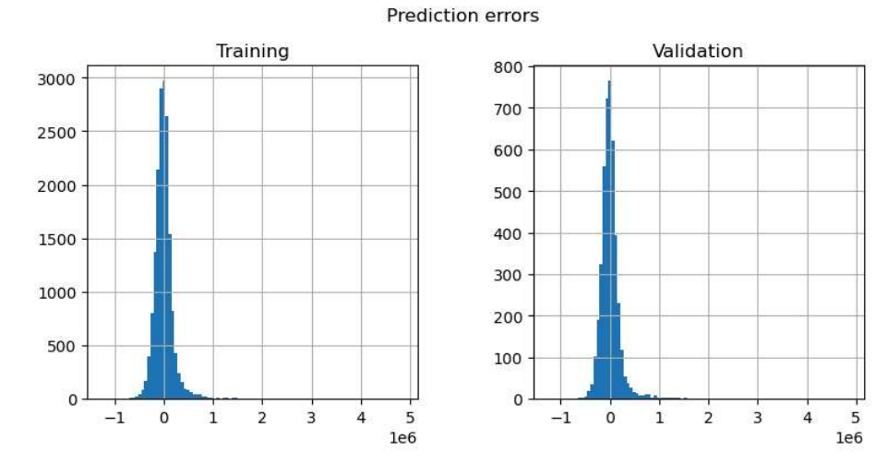
Figure 1. side by side residual histograms

Figure 1 illustrates the prediction errors of both the training and validation datasets in an MLR model. Error values are mostly distributed around zero, proving that the model predictions are close to the actual prices. The compact distribution of the errors means small bias and also indicates the model's consistency across the datasets. Some extreme values on the right tail indicate slight overestimations in the predictions. The two plots (training vs. validation) look similar; they indicate a good generalization and low overfitting. In summary, the model maintains a stable prediction accuracy across both data splits.

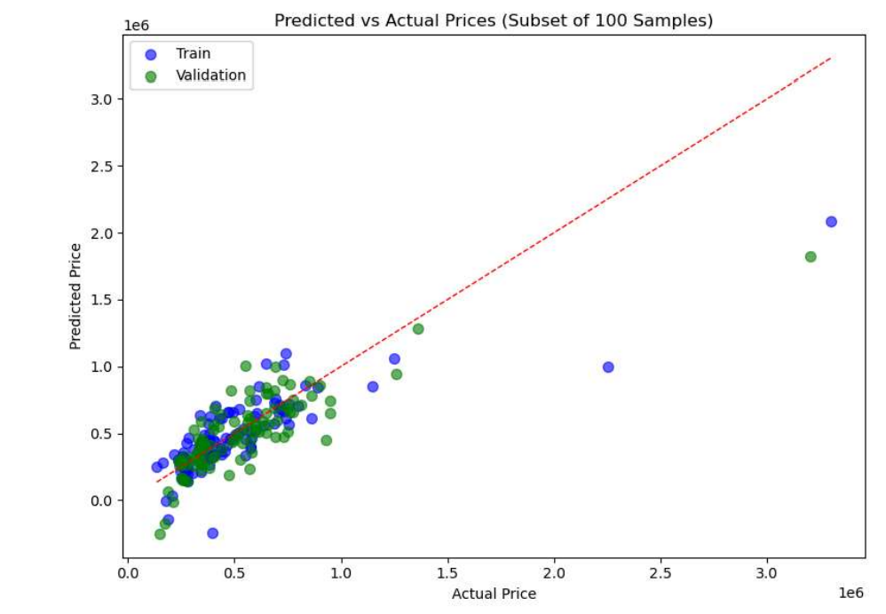
Figure 2. scatter plot(actual vs predicted)

Figure 2 depicts actual versus predicted prices for training and validation datasets based on the Multiple Linear Regression model. A random subset of 100 samples was used to assess model performance. The ideal line of prediction is shown as a red dashed line where the actual and predicted values align perfectly. Most data points cluster around this line, indicating good predictive accuracy and a strong correlation. Slight deviations are observed at higher price values, which might indicate outliers or very minor errors in the prediction; however, overall, the model works well.

6. Discussion

While both models — Multiple Linear Regression (MLR) and K-Nearest Neighbors (KNN) — are effective at predicting home prices, they have different strengths and weaknesses.
The MLR model provides insight into how the data behaves. The model shows that grade, bathrooms, latitude, square footage, and waterfront all increase the price of a home. Conversely, some variables, such as year built (yr_built), can have a small negative impact on price. That is, homes that are higher quality, larger, newer, and in a better location tend to sell for a higher price in the market.
The KNN model takes a different approach — it doesn’t explain the relationship between the variables but simply looks at the prices of similar homes to make predictions for a new home. In this project, the KNN model achieved an RMSE of 172,744, compared to MLR’s RMSE of 216,468. This suggests that it is more accurate in its predictions. However, the KNN model requires more computational power because it compares new data with the entire database each time it is added.
In general, the MLR model is more suitable for explanation and analysis, while the KNN is more suitable for obtaining accurate results.
In terms of practical application:
If the goal is to understand the factors affecting house prices, the MLR is more suitable.
If the goal is simply to make more accurate predictions, the KNN is more appropriate.
These results are also consistent with previous studies (Dong, 2021; Sagala & Cendriawan, 2022; Kanadia & Chawan, 2024), which show that combining data-driven methods and statistical models is the most effective approach to analyzing real estate prices.
Finally, in King Country, prices are determined based on factors such as location, house size, and construction quality. Both models proved that these factors have the greatest impact on market value.

- Conclusion

The main objective of this study was to predict house prices using Multiple Linear Regression (MLR) and K-Nearest Neighbors (KNN) models based on the kc_house_data.csv dataset from King County, Washington. While both models predicted prices correctly, they yielded different results in terms of accuracy and explanation.
The MLR model made the results easier to understand because it clearly showed the impact of each feature on price. The Mean Absolute Percentage Error (MAPE) of this model was about 27%, meaning it predicted prices with 73% accuracy. While this model was not the most accurate, it was useful for finding the main factors affecting price.
The KNN model performed slightly better when K=10, with a lower validation RMSE of 172.744. This model predicted prices more accurately, but it could not explain which features caused the price changes. KNN predicts mainly by comparing similar examples and prioritizes accuracy over explanation.
Overall, the factors that most affected housing prices were grade, bathroom, latitude, sqft_living, and waterfront. This result suggests that location, quality, and house size are the strongest factors that influence price.
Future research could use models such as Random Forest, XGBoost, or Neural Networks to uncover more complex relationships and reduce errors. Combining these models with traditional regression could provide both higher accuracy and better explanatory power.
In conclusion, this project showed that the MLR model is better suited for understanding the causes that affect prices, while the KNN model is better suited for more accurate predictions.

References

[1] James, G., Witten, D., Hastie, T., & Tibshirani, R. (2013). An Introduction to Statistical Learning: With Applications in R. Springer.
[2] Wooldridge, J. M. (2016). Introductory Econometrics: A Modern Approach. Cengage Learning.
[3] Dong, D. (2021). Factors Influencing Housing Prices: An Empirical Analysis From New York City. Proceedings of the 3rd International Conference on E-Business, Information Management and Computer Science, 106–113.
[4] Sagala, N. T. M., & Cendriawan, L. H. (2022). House Price Prediction Using Linear Regression. IEEE 8th International Conference on Computing, Engineering and Design (ICCED), Sukabumi, Indonesia, 1–5.
[5] Kanadiya, P., & Chawan, P. (2024). A KNN-Linear Regression Fusion Approach for Improved Real Estate Price Estimation. ResearchGate.

